Word Report

EASTERN INTERNATIONAL UNIVERSITY

MIS 443
Business Data Management Q4
Assignment 02
Word Report

Lecturer: Dang Thai Doan

Name | IRN | Github Repository link
Phạm Thùy Trang | 2332300158 | https://github.com/TrangPham-25
Tăng Sở Hân | 2332300046 | https://github.com/hants1825-sys/MIS443_Ecommers-Dataset-
Lữ Anh Thư | 2332300138 | https://github.com/thulubbs23-cpu/MIS443_Group_Data_Minds_Ecommerce
Nguyễn Thị Ánh Tuyết | 2332300334 | https://github.com/tuyetnguyenthianhbbs23-collab/MIS-443

1. Introduction
This report documents the design, implementation, and querying of a relational e-commerce database developed as part of MIS 443 Assignment 2. Data Minds group selected the E-Commerce schema from SQL Practice Online and recreated it in PostgreSQL using pgAdmin 4.
The database models a simplified online retail environment in which customers place orders for products organised into categories. The project covers the full development cycle: schema analysis, table creation with integrity constraints, data preparation and loading, and the completion of thirty SQL practice questions ranging from basic retrieval to window functions and common table expressions (CTEs).
The primary objectives of this assignment were to interpret a relational schema, implement it correctly in PostgreSQL, ensure data integrity through primary and foreign keys, and demonstrate proficiency in writing analytical SQL queries that support business decision-making.

2. Selected Database Context
The E-Commerce schema represents the core operational data of a small-to-medium online retailer. It captures customer profiles, a product catalogue structured by category, customer orders, and the individual line items within each order.
From a business perspective, the schema supports typical analytical needs such as:
- Identifying high-value customers and assigning loyalty tiers based on total spend.
- Measuring product and category revenue performance.
- Tracking order fulfilment status (pending, shipped, delivered).
- Detecting products that have never been ordered.
- Ranking products by price within and across categories.
These capabilities align with common business intelligence requirements in retail operations, inventory planning, and customer relationship management.

3. Main Tables and Relationships
The database consists of five normalised tables. The design follows third normal form (3NF) to minimise redundancy while preserving referential integrity.

3.1 Table Overview
Table | Purpose | Key Columns
customers | Customer master data | customer_id (PK), first_name, last_name, email (UNIQUE), registration_date, city, country
categories | Product category catalogue | category_id (PK), category_name, description
products | Product master data | product_id (PK), product_name, category_id (FK), price, stock_quantity, created_date
orders | Customer order headers | order_id (PK), customer_id (FK), order_date, total_amount, status
order_items | Order line items | order_item_id (PK), order_id (FK), product_id (FK), quantity, unit_price

3.2 Relationships
The following one-to-many relationships are enforced through foreign-key constraints:
- customers → orders (one customer may place many orders).
- categories → products (one category contains many products).
- orders → order_items (one order contains many line items).
- products → order_items (one product may appear in many line items).
All foreign keys reference the corresponding primary keys and were created with explicit constraint names (for example, fk_order_customer and fk_product_category) to improve maintainability and error diagnostics.

3.3 Entity–Relationship Diagram
Figure 1 illustrates the complete entity–relationship structure of the E-Commerce database, including primary keys, foreign keys, and cardinalities.
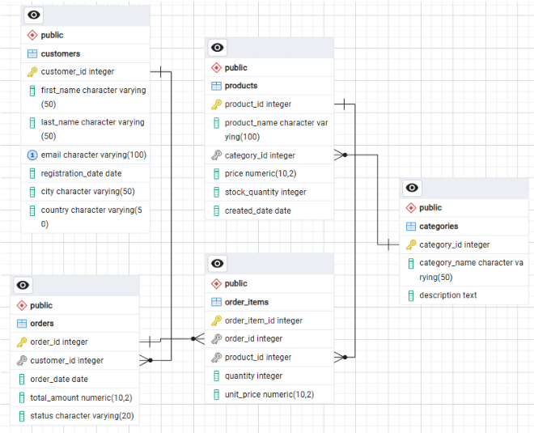
Figure 1. Entity–Relationship Diagram of the E-Commerce schema

4. Summary of Database Implementation
The database was implemented in PostgreSQL and managed through pgAdmin 4. The implementation followed a controlled sequence to respect foreign-key dependencies.

4.1 Structure
- 01_create_database.sql – Creates the ecommerce database.
- 02_create_tables_relationships.sql – Creates all five tables, primary keys, unique constraints, and foreign-key relationships.
- 03_insert_data.sql – Documents the data-loading procedure (CSV import via pgAdmin Import/Export).
- 04_questions.sql – Contains the complete set of thirty SQL solutions with question descriptions as comments.

4.2 Data Preparation
Five CSV files were prepared in the data folder, one for each table. Each file includes a header row with column names that match the database schema. Data volumes are modest but sufficient to exercise all thirty practice questions:
CSV File | Rows | Notes
customers.csv | 6 | Includes one customer without orders and one with a missing city value
categories.csv | 5 | Electronics, Clothing, Books, Home & Garden, Sports
products.csv | 8 | Covers all five categories; one product has never been ordered
orders.csv | 6 | Statuses: delivered, shipped, pending; all orders dated June 2023
order_items.csv | 9 | Line totals are consistent with the total_amount values stored in orders

4.3 Data-Loading Order
Tables were populated in dependency order to satisfy foreign-key constraints:
- customers and categories (independent parent tables)
- products (depends on categories)
- orders (depends on customers)
- order_items (depends on orders and products)

4.4 Integrity Verification
After loading, the following checks were performed:
- Primary-key uniqueness for every table.
- Foreign-key referential integrity (no orphan records).
- Consistency between order_items line totals and orders.total_amount.
- Presence of edge-case records required by specific questions (null city, unordered product, customer without orders).
All thirty questions associated with the E-Commerce schema on SQL Practice Online were completed and tested in pgAdmin. The solutions use PostgreSQL-compatible syntax and are stored in 04_questions.sql with each question description included as an SQL comment.

5. Summary of the 30 SQL Questions

5.1 Question Categories
Topic Area | Questions | Techniques Applied
Basic retrieval | 1–6 | SELECT, WHERE, ORDER BY, COUNT, AVG
Filtering & dates | 7–13 | Equality filters, BETWEEN, DISTINCT, missing value, date arithmetic
Joins | 14–16, 20 | INNER JOIN across two to five tables
Aggregation | 15, 17, 30 | GROUP BY, HAVING, SUM, revenue calculations
Subqueries | 18, 19, 24, 29 | NOT IN, correlated subqueries, scalar subqueries
Outer joins & set ops | 21–22 | LEFT JOIN, COALESCE, UNION ALL with labels
Window functions | 23, 26, 28 | RANK, NTILE, PARTITION BY
CTEs & analytics | 25, 27 | CASE tiering, WITH clauses for max-price-per-category

Core Data Retrieval & Filtering: The initial query block establishes foundational data extraction using basic SELECT statements, sorting (ORDER BY), and initial aggregation (COUNT, AVG) across questions 1–6, followed by precise equity filters, BETWEEN, DISTINCT, missing value, and date arithmetic across questions 7–13.

Aggregation, Joins & Set Operations: Intermediate queries scale complexity through multi-table INNER JOIN operations spanning two to five tables (Questions 14–16, 20), robust revenue calculations leveraging GROUP BY and HAVING (Questions 15, 17, 30), and outer join integrations utilizing LEFT JOIN, COALESCE, and labeled UNION ALL statements (Questions 21–22).

Advanced Subqueries & Analytics: Complex relational requirements are handled using NOT IN, scalar, and correlated subqueries (Questions 18, 19, 24, 29).

Advanced Window Functions & CTEs: Modern analytical techniques incorporate window functions such as RANK and PARTITION BY with quartile distribution via NTILE(4) (Questions 23, 26, 28), alongside conditional CASE tiering and WITH clauses for max-price-per-category computations (Questions 25, 27).

5.2 Representative Business Insights
Several queries produce results that map directly to business questions:
- Revenue & Category Performance: Queries isolate high-yield segments by identifying product categories exceeding specific revenue thresholds (Question 17) and ranking the top five revenue-generating products to guide inventory focus (Question 30).
- Customer Value Segmentation: Advanced queries segment the customer base by evaluating lifetime spend (Question 24), assigning loyalty tiers (Gold, Silver, Bronze) coupled with fulfillment status (Question 25), and distributing purchasers into behavioral quartiles using ranking functions (Question 26).

6. Selected Screenshots from pgAdmin
6.1. Create Database:
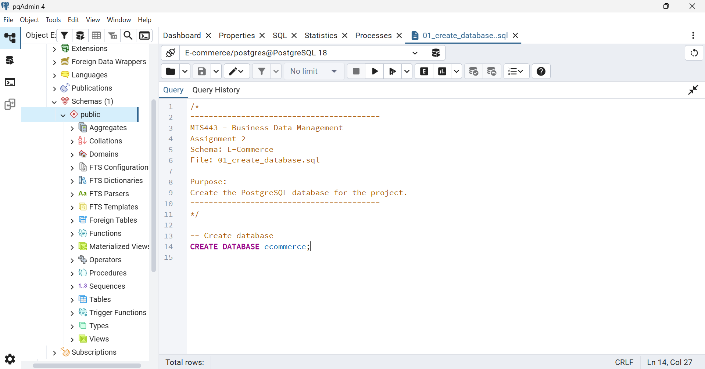

6.2. Create table relationship:
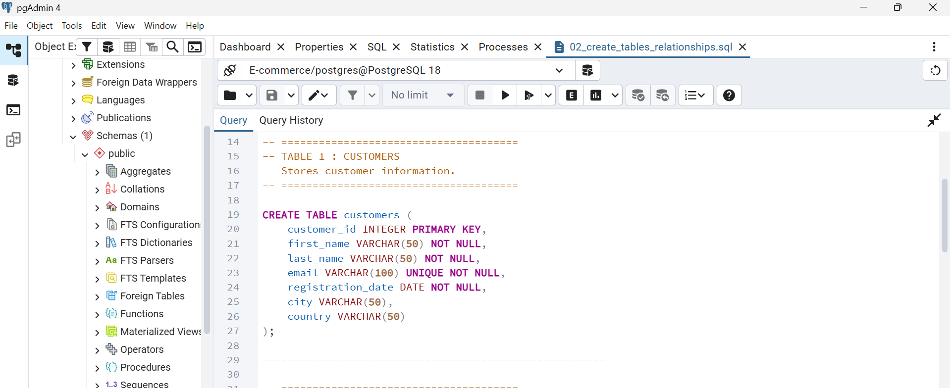

6.3. Insert data:
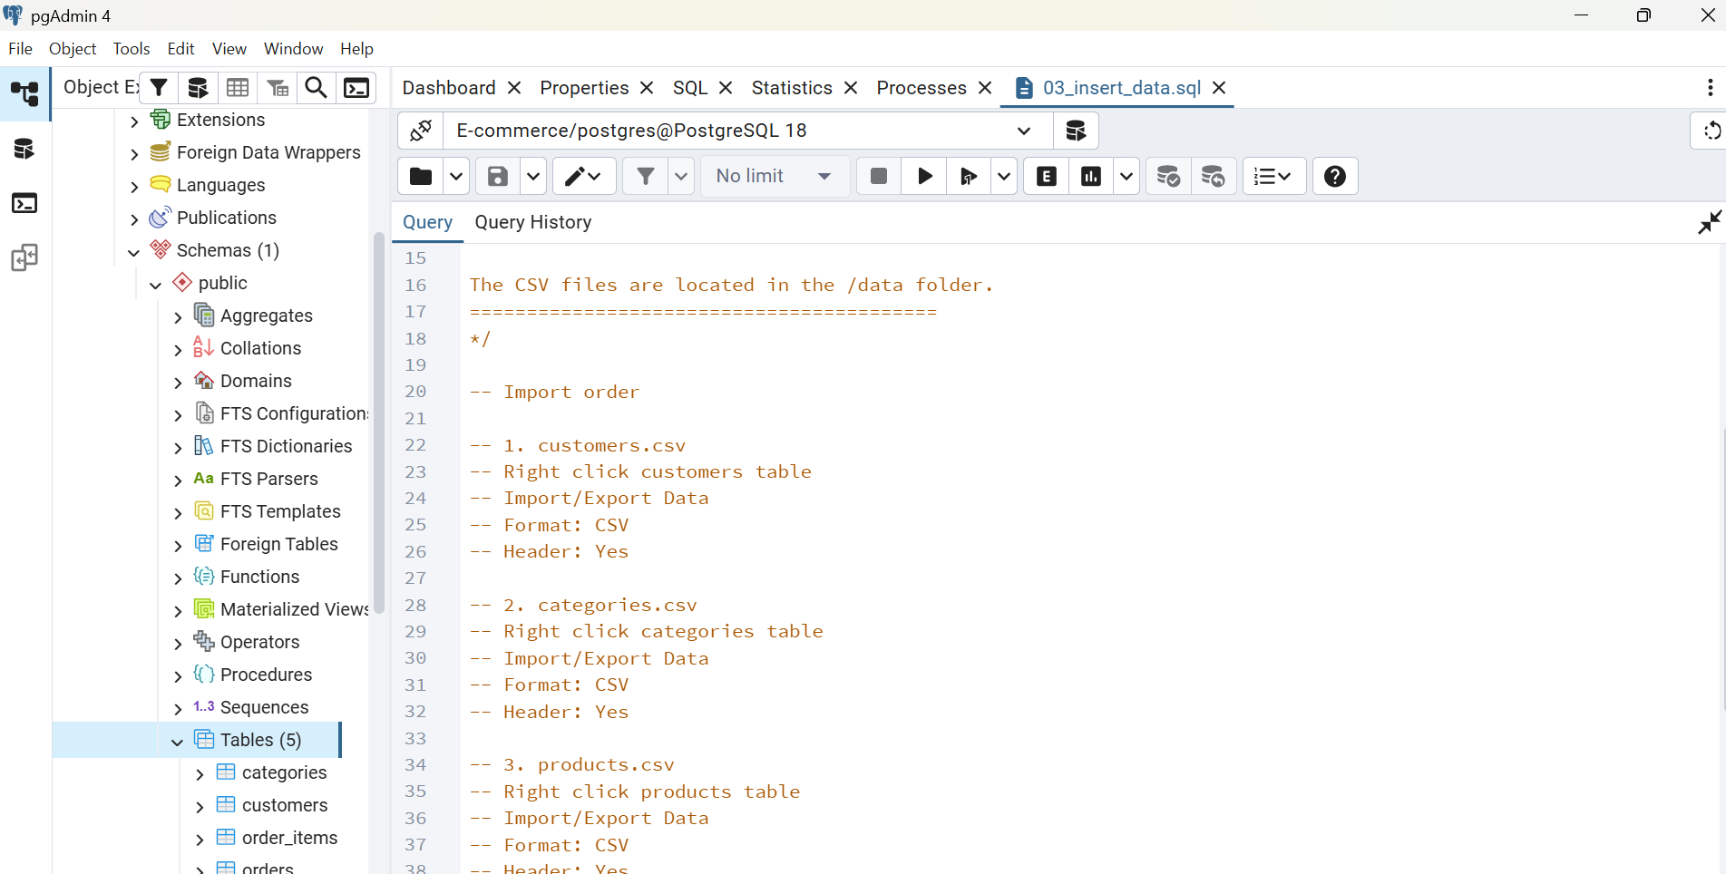

6.4. Questions:
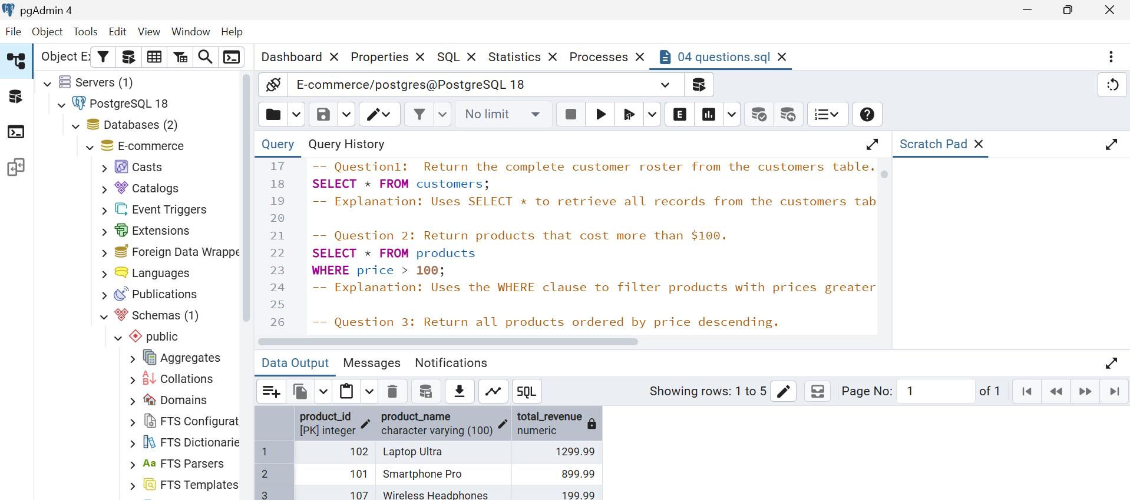

7. Challenges Encountered and Solutions Applied
During the database implementation, our group faced two main technical challenges:

7.1. Data Import Errors Due to Foreign Keys
Challenge: When importing CSV files into pgAdmin, we received foreign key error messages. For instance, importing order_items before orders failed because the referenced order IDs did not exist yet.
Solution: We fixed this by importing data in the correct sequence: parent tables with primary keys (like customers and orders) were filled first, followed by dependent child tables (like order_items).

7. 2. Complex Multi-Table Joins
Challenge: Questions requiring data from 3 or 4 tables (e.g., connecting customers, orders, and products) caused duplicate rows and wrong total sums when using simple JOINs.
Solution: We carefully chose the right join types (LEFT JOIN vs. INNER JOIN), correctly grouped the data using GROUP BY, and double-checked our results with SQL Practice Online.

8. Responsibilities and Contributions of Each Member
Member | Primary Responsibilities
Phạm Thùy Trang | Compiled and finalized the Word report, integrated system screenshots, and reviewed the report layout.
Tăng Sở Hân | Written and formatted the Word report, documented SQL query descriptions, and summarized project findings.
Lữ Anh Thư | Co-authored the final project Word report, structured document sections, and summarized database implementation.
Nguyễn Thị Ánh Tuyết | Executed database operations in pgAdmin 4, created database tables/relationships, imported CSV data, and tested SQL scripts.

9. Conclusion
This project successfully delivered a fully functional PostgreSQL implementation of the E-Commerce schema, complete with referential integrity constraints, a coherent sample dataset, and tested solutions to all thirty associated SQL practice questions.
Through the exercise the group strengthened practical skills in relational modelling, constraint design, data preparation, and analytical SQL. The combination of joins, aggregations, subqueries, window functions, and CTEs covers the core techniques required for business data analysis in a relational environment.
The complete project includes SQL scripts, CSV data files, the entity–relationship diagram, and this report is reproducible from the submitted package and has been published in each member’s personal GitHub repository. The work demonstrates both technical competence and effective team collaboration.

Read me
# MIS443 Assignment 2 – PostgreSQL Database Development and SQL Practice

## Course

**MIS443 – Business Data Management**

## Assignment

**Assignment 2 – PostgreSQL Database Development and SQL Practice**

## Selected Schema

**E-Commerce**

## Group Information

**Group Number:** Data Minds

**Members:**

* LU ANH THU – 2332300138
* TANG SO HAN – 2332300046
* PHAM THUY TRANG – 2332300158
* NGUYEN THI ANH TUYET – 2332300334

---

# Project Description

This project was completed as part of the MIS443 Business Data Management course. The objective is to recreate the E-Commerce database from SQL Practice Online using PostgreSQL and pgAdmin.

The project includes database creation, table relationships, CSV data preparation, data insertion, and SQL solutions for all 30 practice questions.

---

# Tools Used

* PostgreSQL
* pgAdmin 4
* SQL Practice Online
* Microsoft Word
* GitHub

---

# Folder Structure

```text
MIS443_Group_Data_Minds_Ecommerce/
│
├── codes/
│ ├── 01_create_database.sql
│ ├── 02_create_tables_relationships.sql
│ ├── 03_insert_data.sql
│ └── 04_questions_01_30.sql
│
├── data/
│ ├── *.csv
│
├── report/
│ └── MIS443_Group_Data_Minds_Report.docx
│
└── README.md
```

---

# How to Run the Project

1. Open PostgreSQL and pgAdmin.
2. Execute **01_create_database.sql**.
3. Execute **02_create_tables_relationships.sql**.
4. Execute **03_insert_data.sql**.
5. Execute **04_questions_01_30.sql**.
6. Verify that all 30 SQL queries execute successfully.

---

# SQL Practice Online

https://www.sql-practice.online/practice/hr?engine=postgresql

**Selected Schema:** E-Commerce

---

# Acknowledgement

This project was completed collaboratively by all group members as part of the MIS443 Assignment 2 requirements. Each member maintains an individual public GitHub repository containing the same final version of the project.

Github cá nhân

.5 Individual GitHub Repository
Although the technical work is completed as a group, each member must create a repository in their own personal GitHub account.
Each member must:
- Create a public GitHub repository for the assignment.
- Upload the complete and final group project.
- Maintain the required folder structure.
- Include a README.md file.
- Provide their personal GitHub repository link in the Word report and Moodle submission.

Thẻ 5
Assignment 2 - PostgreSQL Database Development and SQL Practice
Contents
1. Assignment Description. 2
2. Assignment Objectives. 2
3. Required Tools. 3
4. Assignment Requirements. 3
4.2 Data Preparation. 3
4.3 SQL Questions. 4
4.4 Word Report 4
4.5 Individual GitHub Repository. 5
5. Required Submission Files. 5
6. Moodle Submission. 6
7. Important Notes. 7

Students will use the PostgreSQL practice databases available at:
SQL Practice Online:
https://www.sql-practice.online/practice/hr?engine=postgresql
From the Schema menu, groups may select one of the following databases:
- HR
- E-Commerce
- Healthcare c
- Banking

1. Assignment Description
In this group assignment, students will recreate and query a relational database based on one schema provided by SQL Practice Online.
Each group must select one schema, and different groups are not permitted to select the same schema. Schema selection must be registered with the lecturer before beginning the assignment.
Using PostgreSQL and pgAdmin, each group must independently:
- Analyse the selected schema.
- Create the database and its tables.
- Define appropriate relationships and constraints.
- Prepare and insert the required data.
- Complete all 30 SQL questions provided for the selected schema.
- Document the completed work in a Word report.
- Publish the complete project in each member’s personal GitHub repository.
Students are responsible for determining appropriate data types, keys, constraints, table-creation order, data-insertion order, and SQL solutions.

2. Assignment Objectives
Upon completing this assignment, students should be able to:
- Interpret a relational database schema.
- Create and manage a PostgreSQL database using pgAdmin.
- Create tables with suitable data types and constraints.
- Define primary keys, foreign keys, and table relationships.
- Prepare structured data in CSV format.
- Insert and verify data in PostgreSQL tables.
- Write SQL queries for retrieving and analysing business data.
- Apply filtering, sorting, joins, aggregation, subqueries, and other relevant SQL techniques.
- Organise and document a reproducible database project.
- Use GitHub to publish and maintain an individual project portfolio.
- Collaborate effectively as a project team.

3. Required Tools
Students must use:
- PostgreSQL as the database management system.
- pgAdmin 4 to create and query the database.
- SQL Practice Online to access the selected schema and its 30 questions.
- Microsoft Word to prepare the group report.
- CSV files to store the data inserted into each table.
- GitHub to publish the complete project in each student’s personal repository.
The PostgreSQL engine must be selected on SQL Practice Online.

4. Assignment Requirements

4.1 Database Development
Each group must recreate the selected database in PostgreSQL, including:
- All required tables and columns.
- Appropriate PostgreSQL data types.
- Primary keys and foreign keys.
- Relationships among tables.
- Relevant constraints for maintaining data integrity.
- Sufficient data to reproduce the expected results of the 30 questions.
The database and all scripts must execute successfully in pgAdmin.

4.2 Data Preparation
Each table must have a corresponding CSV file containing the data used in the database.
The CSV files must:
- Include column headers.
- Use names consistent with the database tables.
- Contain the complete submitted dataset.
- Maintain valid primary-key and foreign-key references.
- Be stored in a folder named data.

4.3 SQL Questions
Each group must complete all 30 questions associated with its selected schema.
The solutions must:
- Use PostgreSQL-compatible syntax.
- Be tested in pgAdmin.
- Produce results consistent with the expected output shown on the website.
- Be clearly numbered from Question 1 to Question 30.
- Include each question description as an SQL comment.
- Be stored in a separate SQL file.

4.4 Word Report
The group report should briefly include:
- Group and student information.
- Introduction to the selected database context.
- Description of the main tables and relationships.
- Entity–Relationship Diagram.
- Summary of the database implementation.
- Summary of the 30 SQL questions completed.
- Selected screenshots from pgAdmin.
- Challenges encountered and solutions applied.
- Responsibilities and contributions of each member.
- Conclusion.
The report should summarise the work rather than reproduce all SQL code.

4.5 Individual GitHub Repository
Although the technical work is completed as a group, each member must create a repository in their own personal GitHub account.
Each member must:
- Create a public GitHub repository for the assignment.
- Upload the complete and final group project.
- Maintain the required folder structure.
- Include a README.md file.
- Provide their personal GitHub repository link in the Word report and Moodle submission.
The README.md should contain: (optional: this part easy to create with AI support)
- Course and assignment title.
- Selected schema.
- Group number and member names.
- Brief project description.
- Tools used.
- Folder structure.
- Instructions for running the SQL scripts.
- Link to the SQL Practice Online source.
- Acknowledgement that the project was completed as a group.
All group members must upload the same final version of the project. Each repository must remain accessible until grading is completed.

5. Required Submission Files
The submission must contain:
MIS443_GroupXX_SchemaName/
│
├── codes/
│ ├── 01_create_database.sql
│ ├── 02_create_tables_relationships.sql
│ ├── 03_insert_data.sql
│ └── 04_questions_01_30.sql
│
├── data/
│ ├── table_01.csv
│ ├── table_02.csv
│ └── ...
│
├── report/
│ └── MIS443_GroupXX_SchemaName_Report.docx
│
└── README.md
The complete folder must be compressed as:
MIS443_GroupXX_SchemaName.zip

6. Moodle Submission
Only one group member needs to upload the final ZIP file to Moodle. The Moodle submission must also include a list of the personal GitHub repository links of all group members.
The Word report must contain a table similar to the following:
Student Name | Student ID | GitHub Repository Link
Student 1 | ID | Repository URL
Student 2 | ID | Repository URL
Student 3 | ID | Repository URL
Student 4 | ID | Repository URL

7. Important Notes
- Groups must not select the same schema.
- All SQL files must be editable and executable in pgAdmin.
- Screenshots cannot replace SQL scripts or CSV files.
- Table and column names must remain consistent across all files.
- The submitted database must be reproducible from the provided files.
- All 30 SQL questions must be completed.
- Each member must maintain a personal GitHub repository containing the complete project.
- The group is responsible for checking that the ZIP file and all GitHub links work correctly before submission.

End

